**ER Diagram representing Database Requirements**

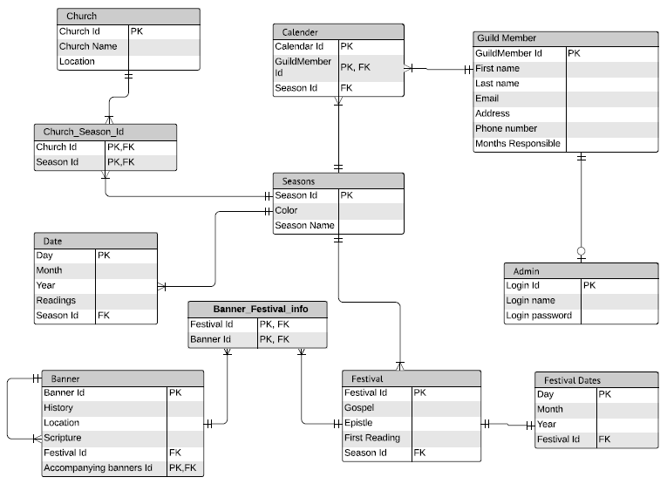

**Link to Lucid chart:**

<https://www.lucidchart.com/documents/edit/89af7560-3539-4419-922d-d8a1d4bfad83/0>